

To excel and contributes in the world of ﬁlms, media and
advertisements which provides challenging opportunities to bring out
the best and maximum of my potential that helps me to explore through learning process.
OBJECTIVE

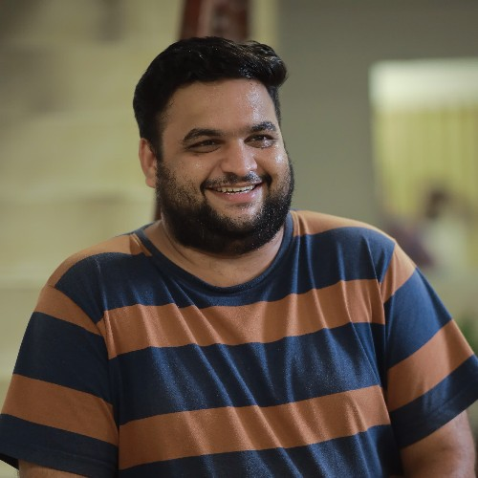EXPERIENCE

VISHNU RAMESH
vishnuramesh1995.vr@gmail.com 8086463656
PAZHOOR (H)
PALISSERY, ANNAMANADA P.O.
THRISSUR, KERALA PIN - 680741

FINFIT ACADEMY
FEB 2024 - SEP 2024
MEDIA HEAD
FINFIT Academy is one of the leading Trading Institution in Kerala
Located at Kottakkal, Malapuram. I'm Currently working there as Social Media & Creative Head.
AARYANS ADVERTISEMENTS
MAR 2022 - SEP 2023
Creative Direction Innovative thinking
Concept development Time management
Interpersonal communication skill Effective marketing strategic
Leadership and relationship building Problem solving skill
Project coordination
SKILLS
CREATIVE DIRECTOR & CONTENT STRATEGIST
Aaryans Advertisements is an advertising agency & digital marketing ﬁrm which specializes in branding, advertising, digital marketing, web designing and hosting, ﬁlm promotions, PR works etc. I worked as creative director and content strategist.
RED BULB ENTERTAINMENTS
DEC 2021 - DEC 2022
CREATIVE DIRECTOR & CONTENT CREATOR
Red bulb entertainments is a production house produces contents, short ﬁlms etc. I worked as a freelance creative director & content creator for one year.
ERU MEDIA
DEC 2021 - DEC 2022
CREATIVE DIRECTOR & CONTENT CREATOR
Eru media is a startup youtube channel which produces
English
Malayalam Hindi Tamil
LANGUAGES
advertisements, web series, short ﬁlms etc. I worked as a freelance creative director & content creator for one year.
SMART CARVING PRODUCTIONS
OCT 2019 - NOV 2021
CREATIVE DIRECTOR & CONTENT WRITER
Smart carving productions is a ﬁlm and advertisement production house. It is a joint venture of smart media lab and digital carving institution. I worked as a freelance creative director and content creator for more than two years for different advertisements, short ﬁlms etc.

Films Books
INTERESTS
EDUCATION

EXCEL INSTITUTIONS, ANNA UNIVERSITY
2014-2018
B. TECH PETROLEUM ENGINEERING
6.4 CGPA
DIGITAL CARVING INSTITUTIONS
2019
DIRECTION & SCRIPT WRITING
Travel

PROJECTS

Film
Creative Producer - 23 Dreams Production No.1 in Association with Vajra Films starring Urvashi, Bhavana, Sreenath Bhasi in leading with supporting of Priya Warrier, Anagha Narayanan, Malavika Sreenath,
Maniyan Pilla Raju, Nandu, Jayaraj Warrier, Althaf Salim, Abhi Ram etc (Post Production Stage)
Film
AMOR starring Mareena Micheal, Karthik Shankar in lead (As Associate director. A direct ott releasing ﬁlm. Post production stage)
Film Scripts
As Script Writer. Untitled project for associate director of SURESHGOPI251 (comedy entertainer) (Scripting Stage)
As Script Writer. Untitled project for VAJRA Films (political satire) (Scripting Stage)
Branding & Advertisements KERALA TOURISM
GOOD DAY TOOTHPASTE
123 TUITION APP
PULSE UK INTERNATIONAL RED & BLACK SHIRTS
THINLAC EPOXY
SAMUDRIKA SILVER
MUDRA KUTHAMPULLY LEO INSTITUTIONS
MECH24 HITECH AUTOPLANT
Web Series
THE POCKET BOOK APPANUM MONUM
Short Films
UMI : THE WAY OF FIRE RESUME ANCHUKANNAN
THE ALPHA JAAN
POLICE KALLAN

